**Assignments on String**

1. Using features of Java 11, read the data from a text file (File name: StudentList.txt). Calculate the count of students and print the names as well as the total count of students on the screen. (If any line in file doesn’t contain a name, for such a record blank space should not be printed in the output)

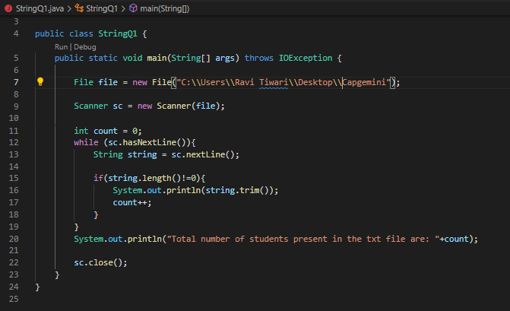

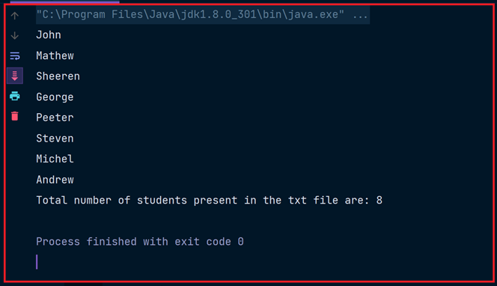

2. Write a program with menu to accept the price of certain items and display their total.

When user selects Option 1: should accept the prices of different products and insert

these prices into first file (each amount to be inserted in a newline in the file). Next,

total of these values should be saved in a new file. Option 2: should allow the user to

view the total of these prices from the second file.

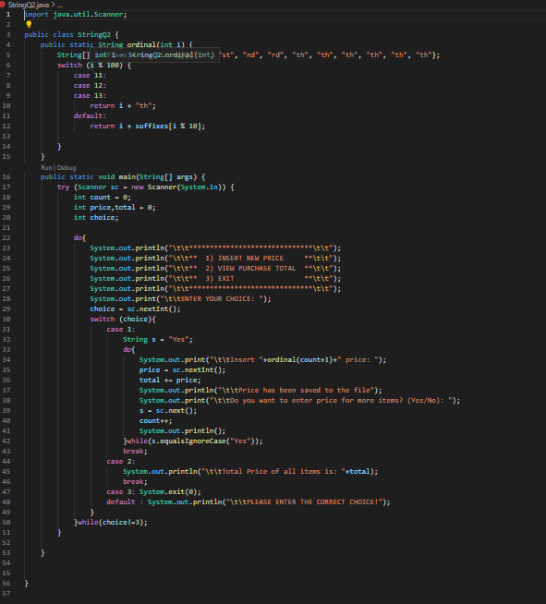

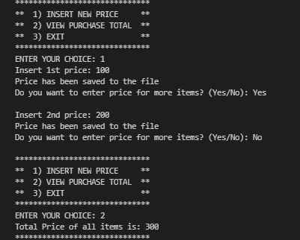

3. Write a code using HttpClient API which sends a GET request

to https://httpbin.org/get, and print out the response header, status code, and

body for the given URL.

